Interpolation doesnt do anything significant to plots except changing location of

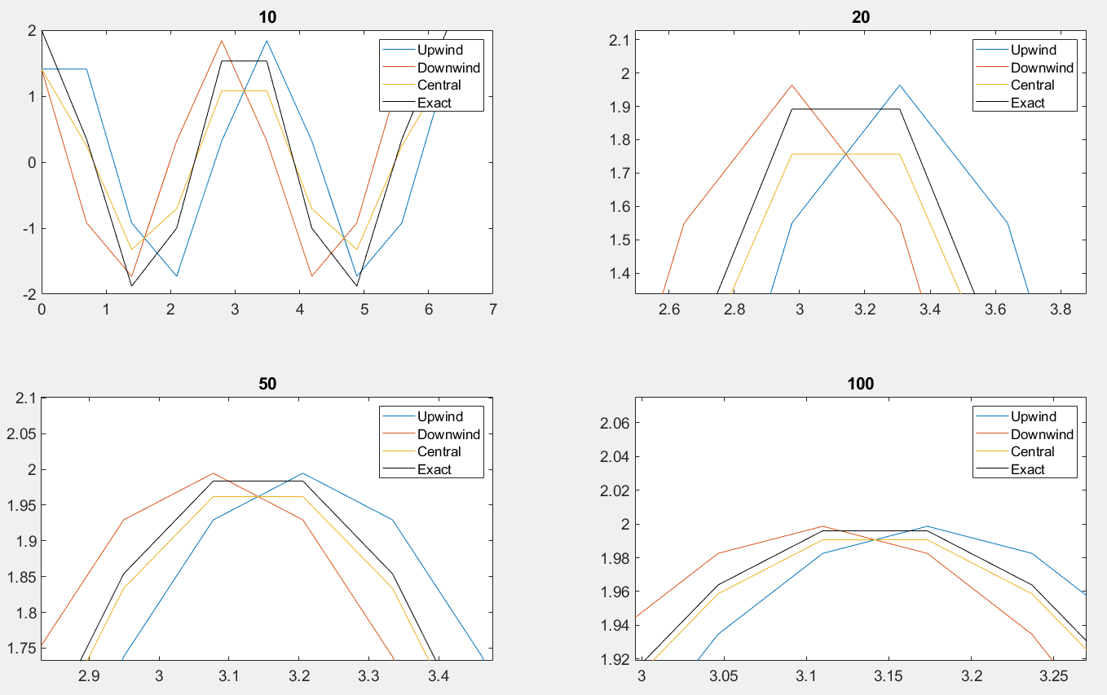

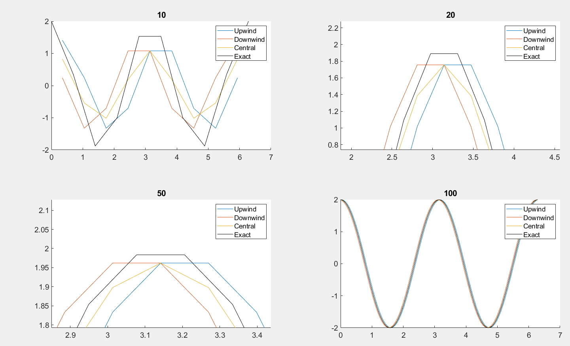

Detail of Error First Derivative (above) and interpolated First Derivative (below)

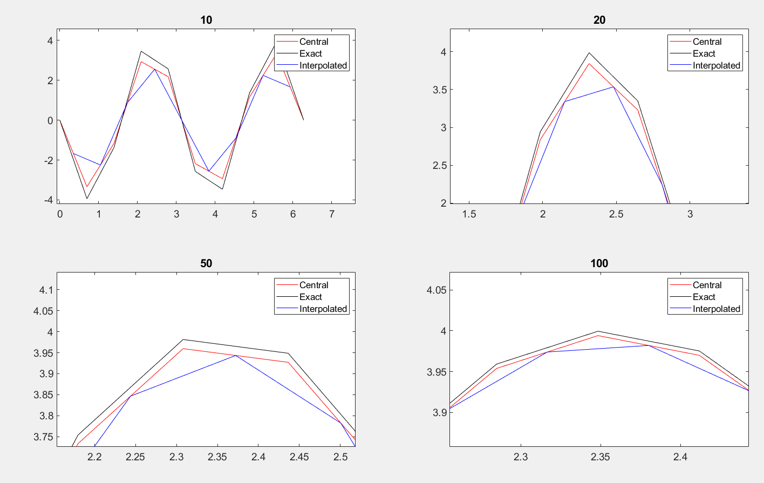

Detail of Error 2nd Derivative





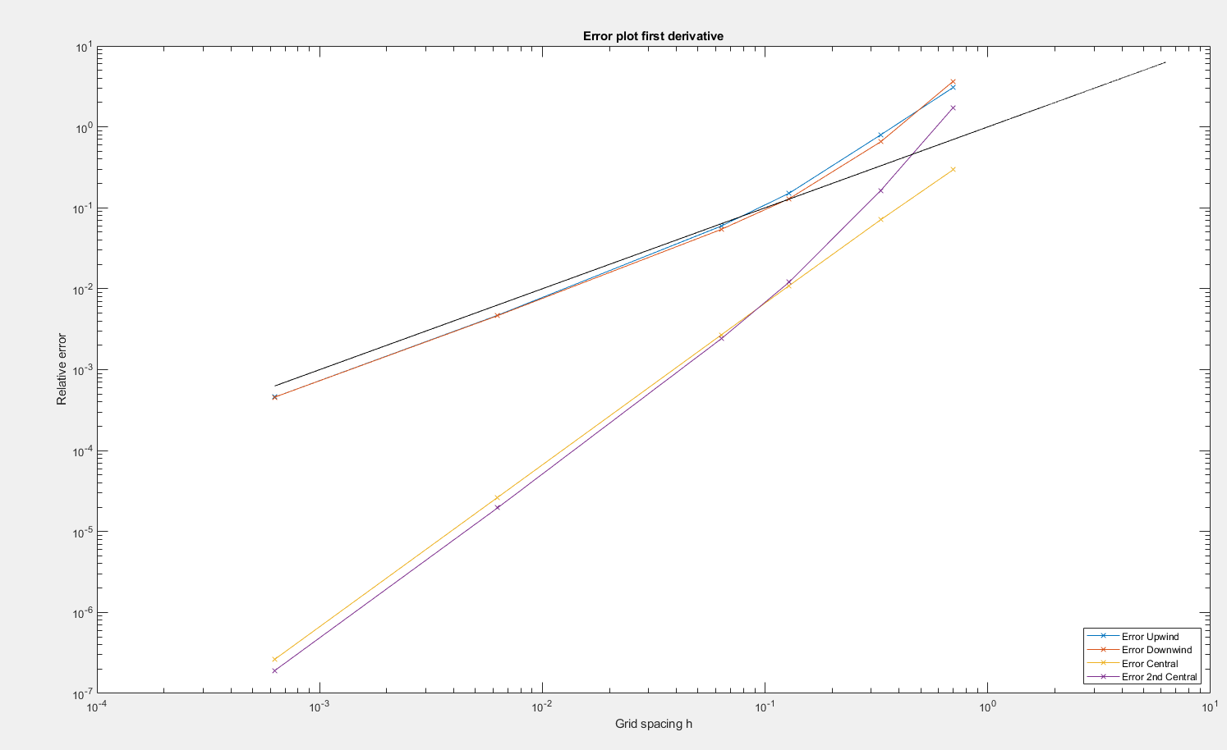

Error Plot first and second Derivatives